Potato Bread Recipe Using Real Mashed Potatoes
- 7 ounces cooked potato (you can use leftover mashed potatoes, or cook up a small potato and mash it)
- Water, enough to equal 1 3/4 cup when combined with the potato
(I put the potato into a 2 cup pyrex measuring cup, and add water to bring the level up to 1 3/4 cup)
- 2 tablespoons softened butter
- 2 1/2 tablespoons sugar (or honey)
- 1 teaspoon sea salt
- 3 1/2 cups bread flour (I usually use a mix of fresh ground wheat flour and pre-milled flour)
- 2 teaspoons dry yeast or 1 1/2 teaspoons saf-instant yeast
If using a bread machine, select “wheat”, “sweet”, or “white” setting, do not use a timer.
I normally mix the dough in my Bosch Universal Plus Kitchen Machine and then bake it in the oven. (I finally bought a Bosch after killing three different bread machines. It’s more expensive, but can handle double batches of whole wheat bread without a fuss, unlike lighter machines.)
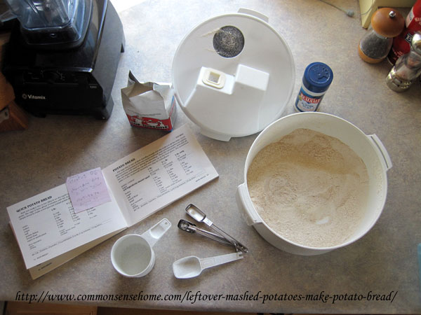
Gathering ingredients – yeast, sea salt, freshly ground flour from the Nutrimill
I add everything into the machine and mix for 6-8 minutes, adding additional flour if needed. Add the last of flour slowly – you want a soft, elastic dough. Too much flour will give you a harder dough and a drier bread. If kneading by hand, mix wet ingredients with yeast until thoroughly blended, then add dry ingredients, adjusting flour as needed to give a soft, elastic dough. This dough will be a little bit more sticky than many bread doughs. This is normal. If you look closely, you can see little bits of brightly colored blue potato.
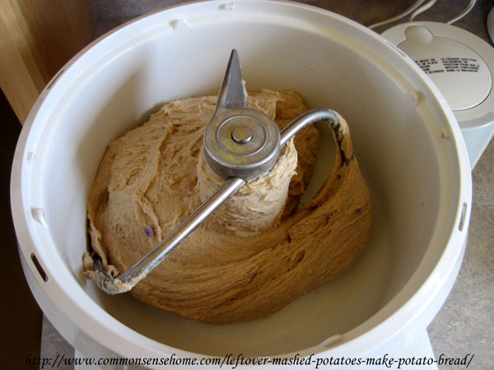
Let bread rest and rise for around 20 minutes, then punch down and allow to rise again. (This develops the flavor and gluten of the bread.)
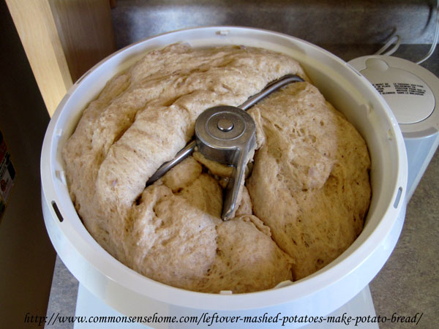
Once doubled in size, form dough into loaves and place in greased bread pans. A single recipe makes one large loaf or two smaller loaves. I usually divide the dough into two 9×5 pans, or make a double batch (shown here) and divide it into three regular loaves. When I bake, I like to make more than one loaf so I can keep the extras in the freezer to have on hand when needed.
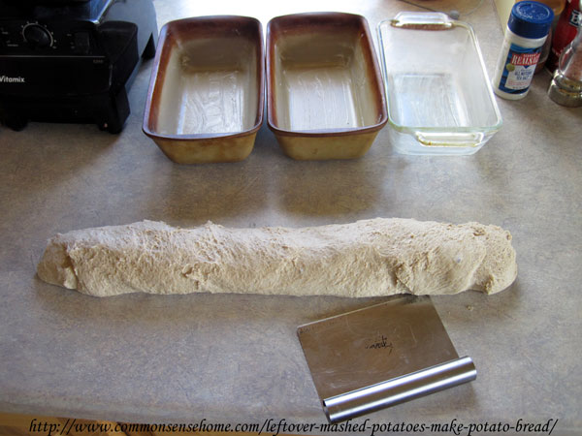
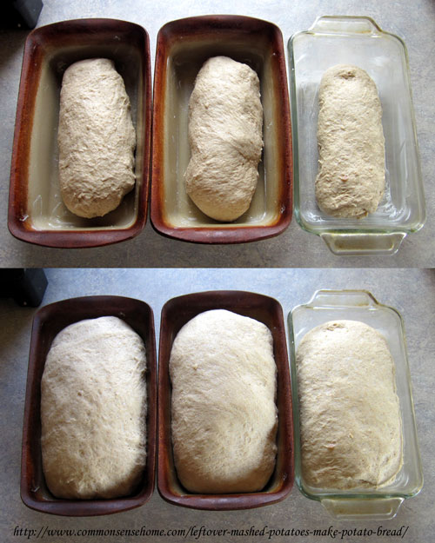
Bread loaves in pan, before and after rising.
Preheat oven to 350F. Bake for 25-30 minutes, until golden brown. Remove from pans and cool on wire racks. Try to wait for the bread to cool before cutting, if possible. When you cut open a steaming loaf of bread, much of the moisture escapes as steam, leaving the remainder of the loaf dry. Of course, if it all disappears within a matter of minutes, this is a non-issue. I let this batch rise a bit too much, which is why the finished loaves (shown below) don’t look quite so picture perfect. Remember, bread will rise a bit in the oven, so bake before it is overflowing the pans. (And don’t get involved in another project and forget about your bread…)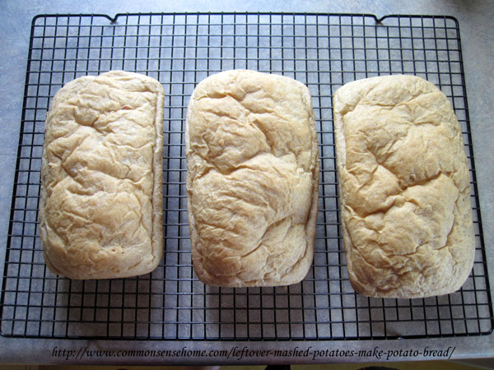
This recipe produces a moist, dense loaf that is great for sandwiches and toast, and holds for the better part of a week. For longer storage, it freezes very well, in case you want to make a double or triple batch.
I hope your family enjoys this recipe as much as my family does. If you do, please pass it along.

